Erosion and Glaciers
______________________ is the movement of sediment or soil from one location to another by means of water, ice, and wind.
______________________ is the breaking down of materials such as rocks and minerals by physical, chemical or biological processes
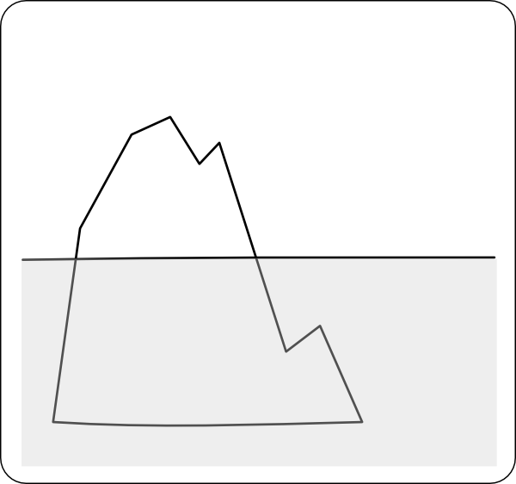
A GLACIER is: ___________________________________________________________
______________________________________________________________________.
Glaciers can be found on _____________________ and on ______________________.
________________________: long, slow-moving, rivers of ice found in areas of high elevation.
____________________________: a very old, thick mass of ice covering almost an entire land mass.
____________________________: is the part of the glacier where the snow builds up (collects) If there is more snow collecting than snow melting, the glacier grows.
____________________________: is where melting (happens). If there is more melting than snow falling, the glacier gets smaller .

Evidence of Glaciers:
______________ is the wearing down
of rock by the grinding effect of rock
fragments frozen into the bottom of
glaciers.

___________________ is when rock and soil picked
up and moved by a glacier is dropped off in a new
area to create new landscapes.

ICE AGES:

Ice Ages are periods when the Earth’s climate ____________ enough to allow large

continental glaciers to flow from the _________ regions to regions farther

____________.

There have been at least _________ ice ages during the past million years.
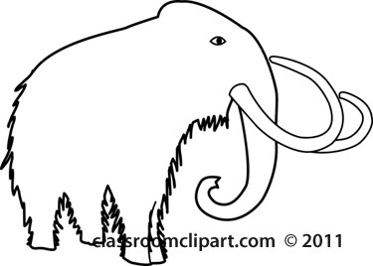

The last ice age was called
___________________________
and it occurred 11,000 years
ago.

During the
"Great Ice Age”
over ______________
of the earth was
covered in ice.

